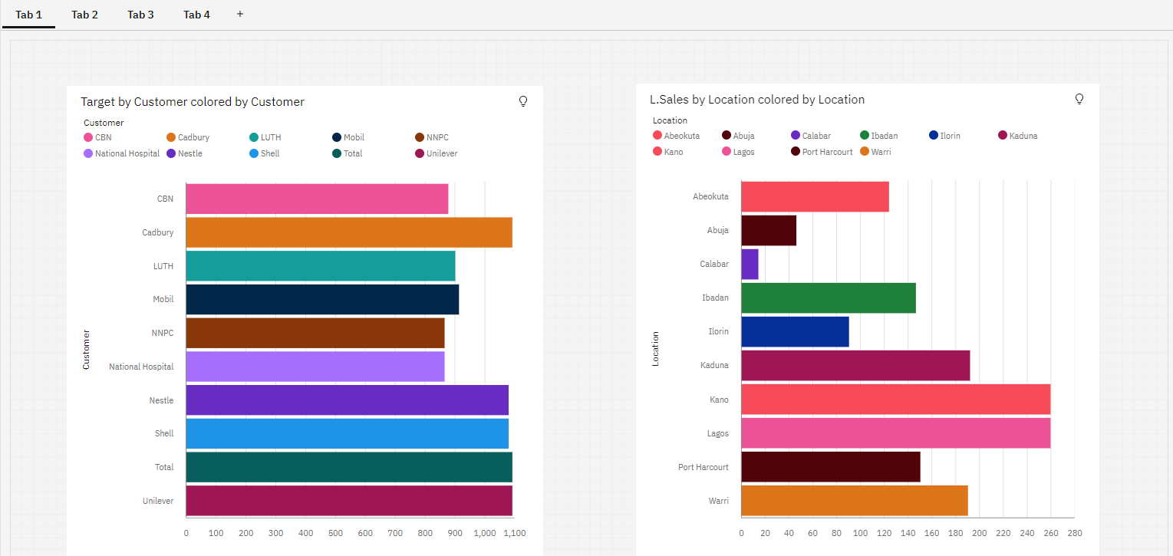Assignment-2

|  |  |
| --- | --- |
| Assignment Date | 16 November 2022 |
| Student Name | Madhumitha R |
| Student Roll Number | 813819104048 |
| Maximum Marks | 2 Marks |

